**Installing Angular2 In Visual Studio 2017**

1. Install Node and Npm from node.org and after installing the node please check the version of node and npm by running the node -v and npm -v command in the cmd pmt.

***Note : The node version should be 4.6.x or greater and npm version should be 3.x.x. or greater.***

1. Install the Visual studio 2017 and change the environment settings to make npm to pick the global path settings by default by navigating to VS2017-> Tools -> Options -> Projects and Solutions -> External Web Tools   
   Make the $Path variable on the second place by selecting the upward key arrow on the right hand side.

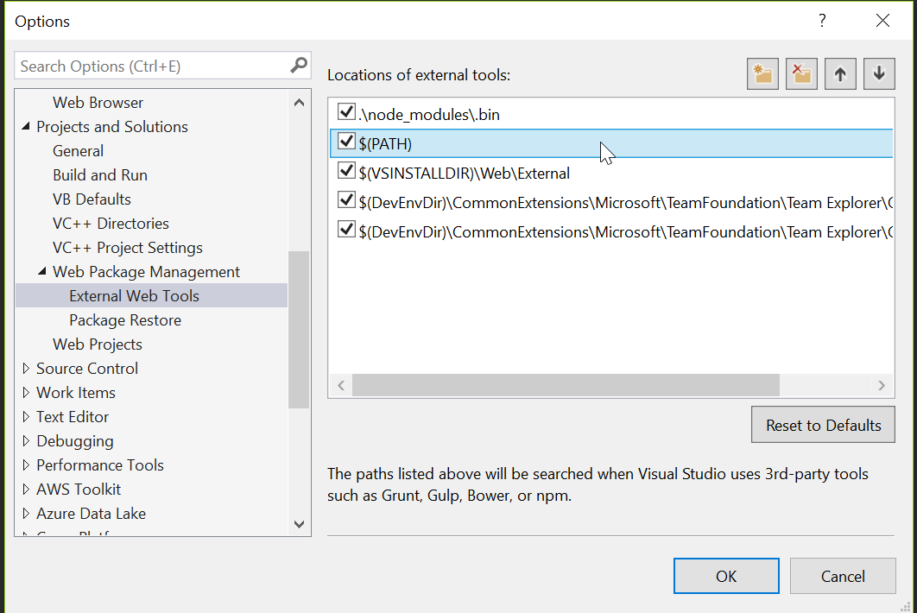

1. Then install the typescript for visual studio 2017 by navigating to the url  
   <https://www.microsoft.com/en-us/download/details.aspx?id=55258> and version should be 2.2 or above
2. Then open the visual studio and create an empty web application.
3. Then install the angular quickstart file from the github by navigating to the location  
   <https://github.com/angular/quickstart>
4. Once the files are downloaded as a zip folder then extract the files and copy the below mentioned files and folders and copy into the root directory of the web application that we have created into step 4.  
     
   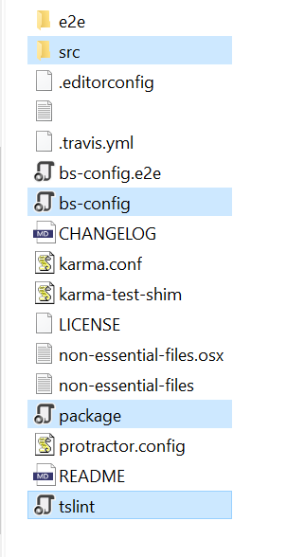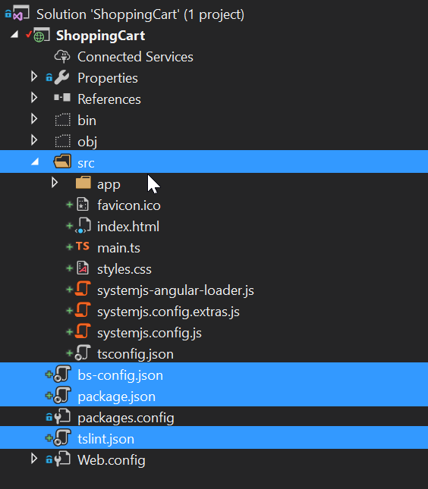
5. Once copied then click on show all files and include them in the project.
6. Then right click on the package.json and restore the required packages into the application.
7. Once the packages are installed you can view the node_module folder inside the root directory of the application which will we visible only when you click show click option but remember not to include this folder into the application and it is for the test purpose.  
   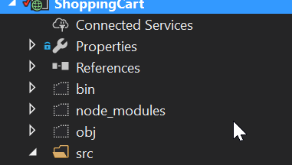
8. Then open the command prompt and navigate to the root directory of the web application and type npm start command to start the angular2 application and once all the components are loaded successfully for the angular 2 then the Hello Angular message will be displayed on your browser.



1. Once installed then build your application and if you face any compilation error the edit the csproj file of your application and disable the typescript compilation by placing the following tag inside the .csproj file of the application.

<TypeScriptCompileBlocked>true</TypeScriptCompileBlocked>

